

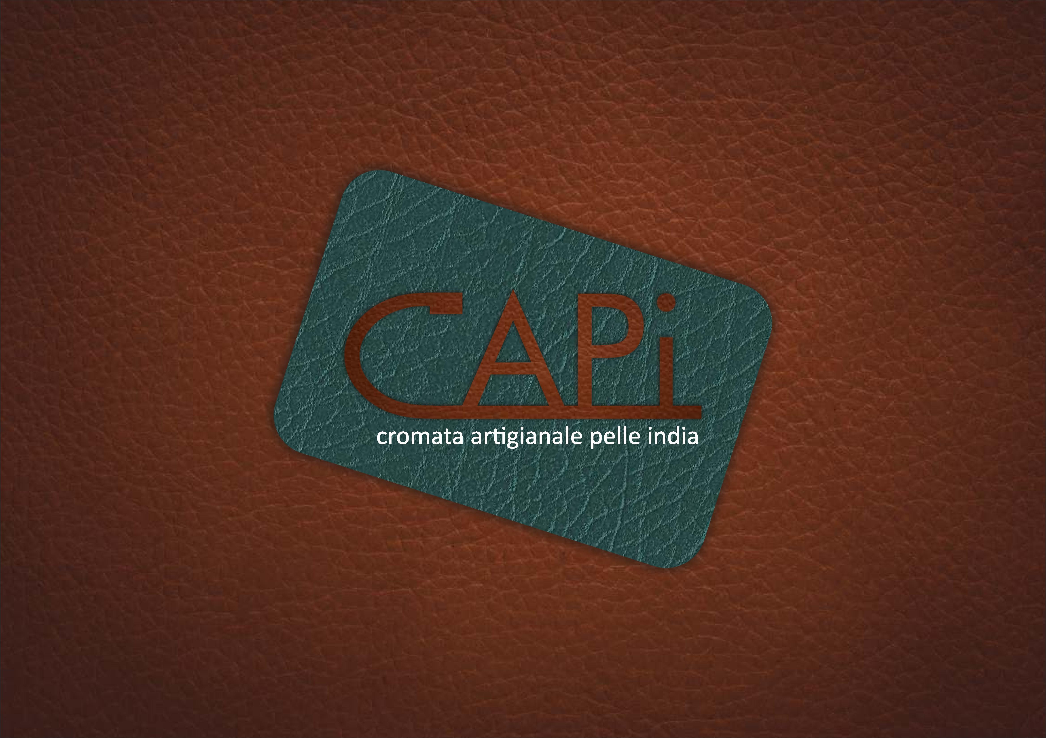

**cromata artigianale pelle India**

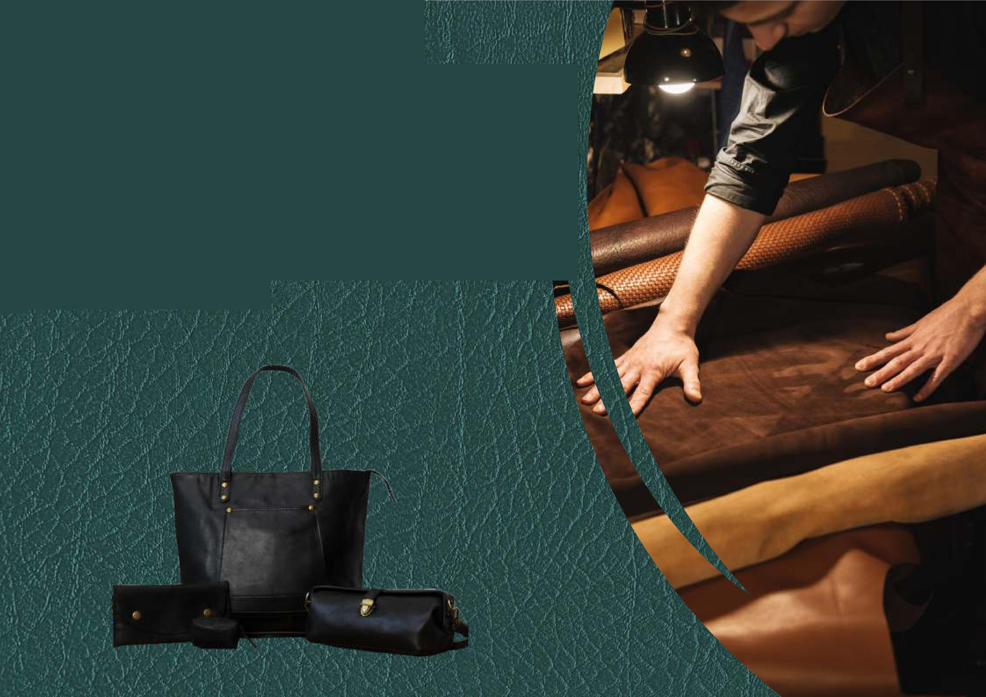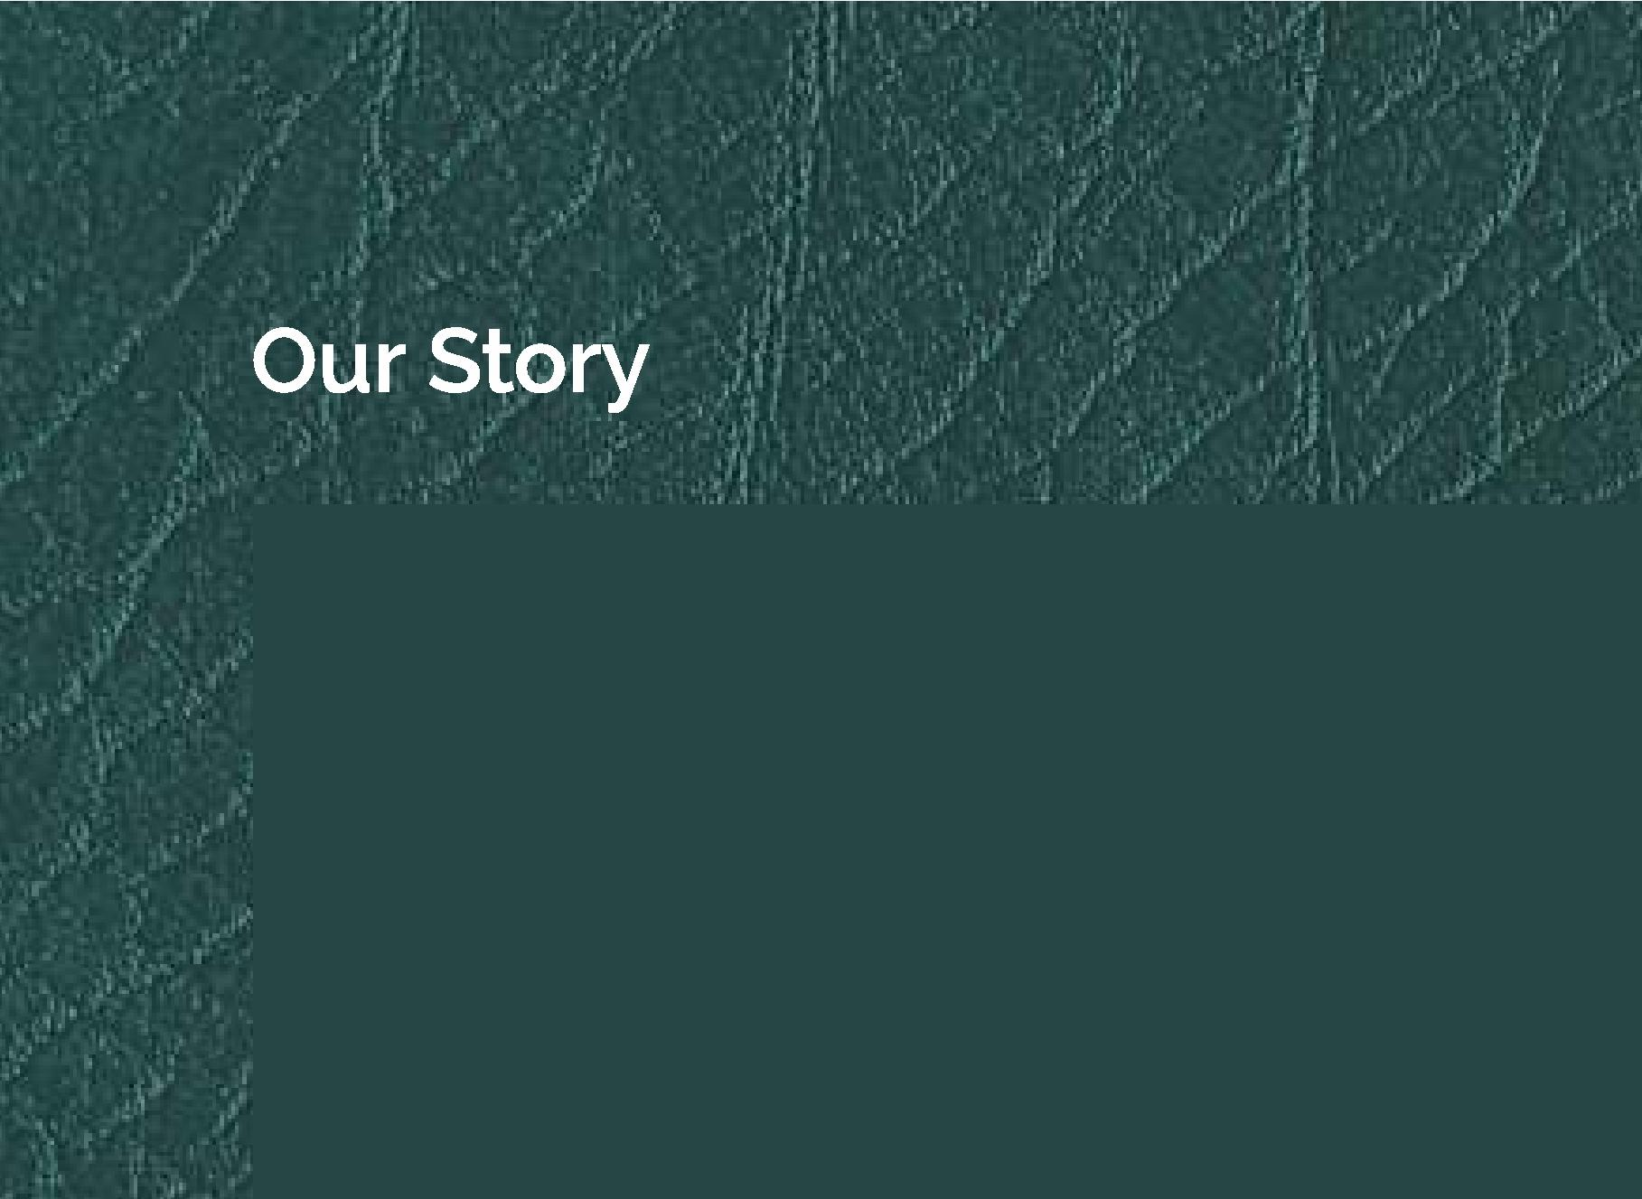F'**4**

**1 11 r**

r.

**We are a leather product company that takes pride in** ou**r**s**- ,**

**craftsmanship, sustainability efforts, and customization if )**

•

1 '

**options. Our journey began with a passion for creating 1 e ti'. high-quality leather goods that stand the test of time. Today, we continue to uphold that tradition while also embracing new technologies and materials to innovate**

**.**

**and improve our products.**

|  |  |  |
| --- | --- | --- |
|  | **BAGS COLLECTION**   * **Our bags collection features a range of styles, from tote bags to backpacks, each crafted with the highest quality leather and attention to detail.**   **WALLETS COLLECTION**   * **Our wallets collection offers a variety of options, including cardholders, billfolds, and coin purses, all made with premium leather and expert craftsmanship.** * **LEATHERAPPARELCOLLECTION Our leather apparel collection includes jackets, vests, and pants, all made with the same attention to detail and quality materials as our bags and wallets.** |  |
|  |
|  |  |

**PRODUCTS COLLECTION**



**CRAFTSMANSHIP**



**Our bags are crafted with precision and care, using only the finest materials and techniques.**

**MATERIALS**



**We use high-quality leather and hardware to ensure that our bags are both durable and stylish.**

**CUSTOMIZATION**



**We offer a range of customization options, including monogramming and color choices, to make your bag truly unique.**

|  |
| --- |
| **Our five important reasons for association and business with us** |

|  |
| --- |
| **Zero Tolerance Product as per requirement**  **Variety Wide range of products** |

|  |
| --- |
| **Capacity We have great capacity to deliver client orders** |

**Commitment Committed to 'ntegrity, transparency and**

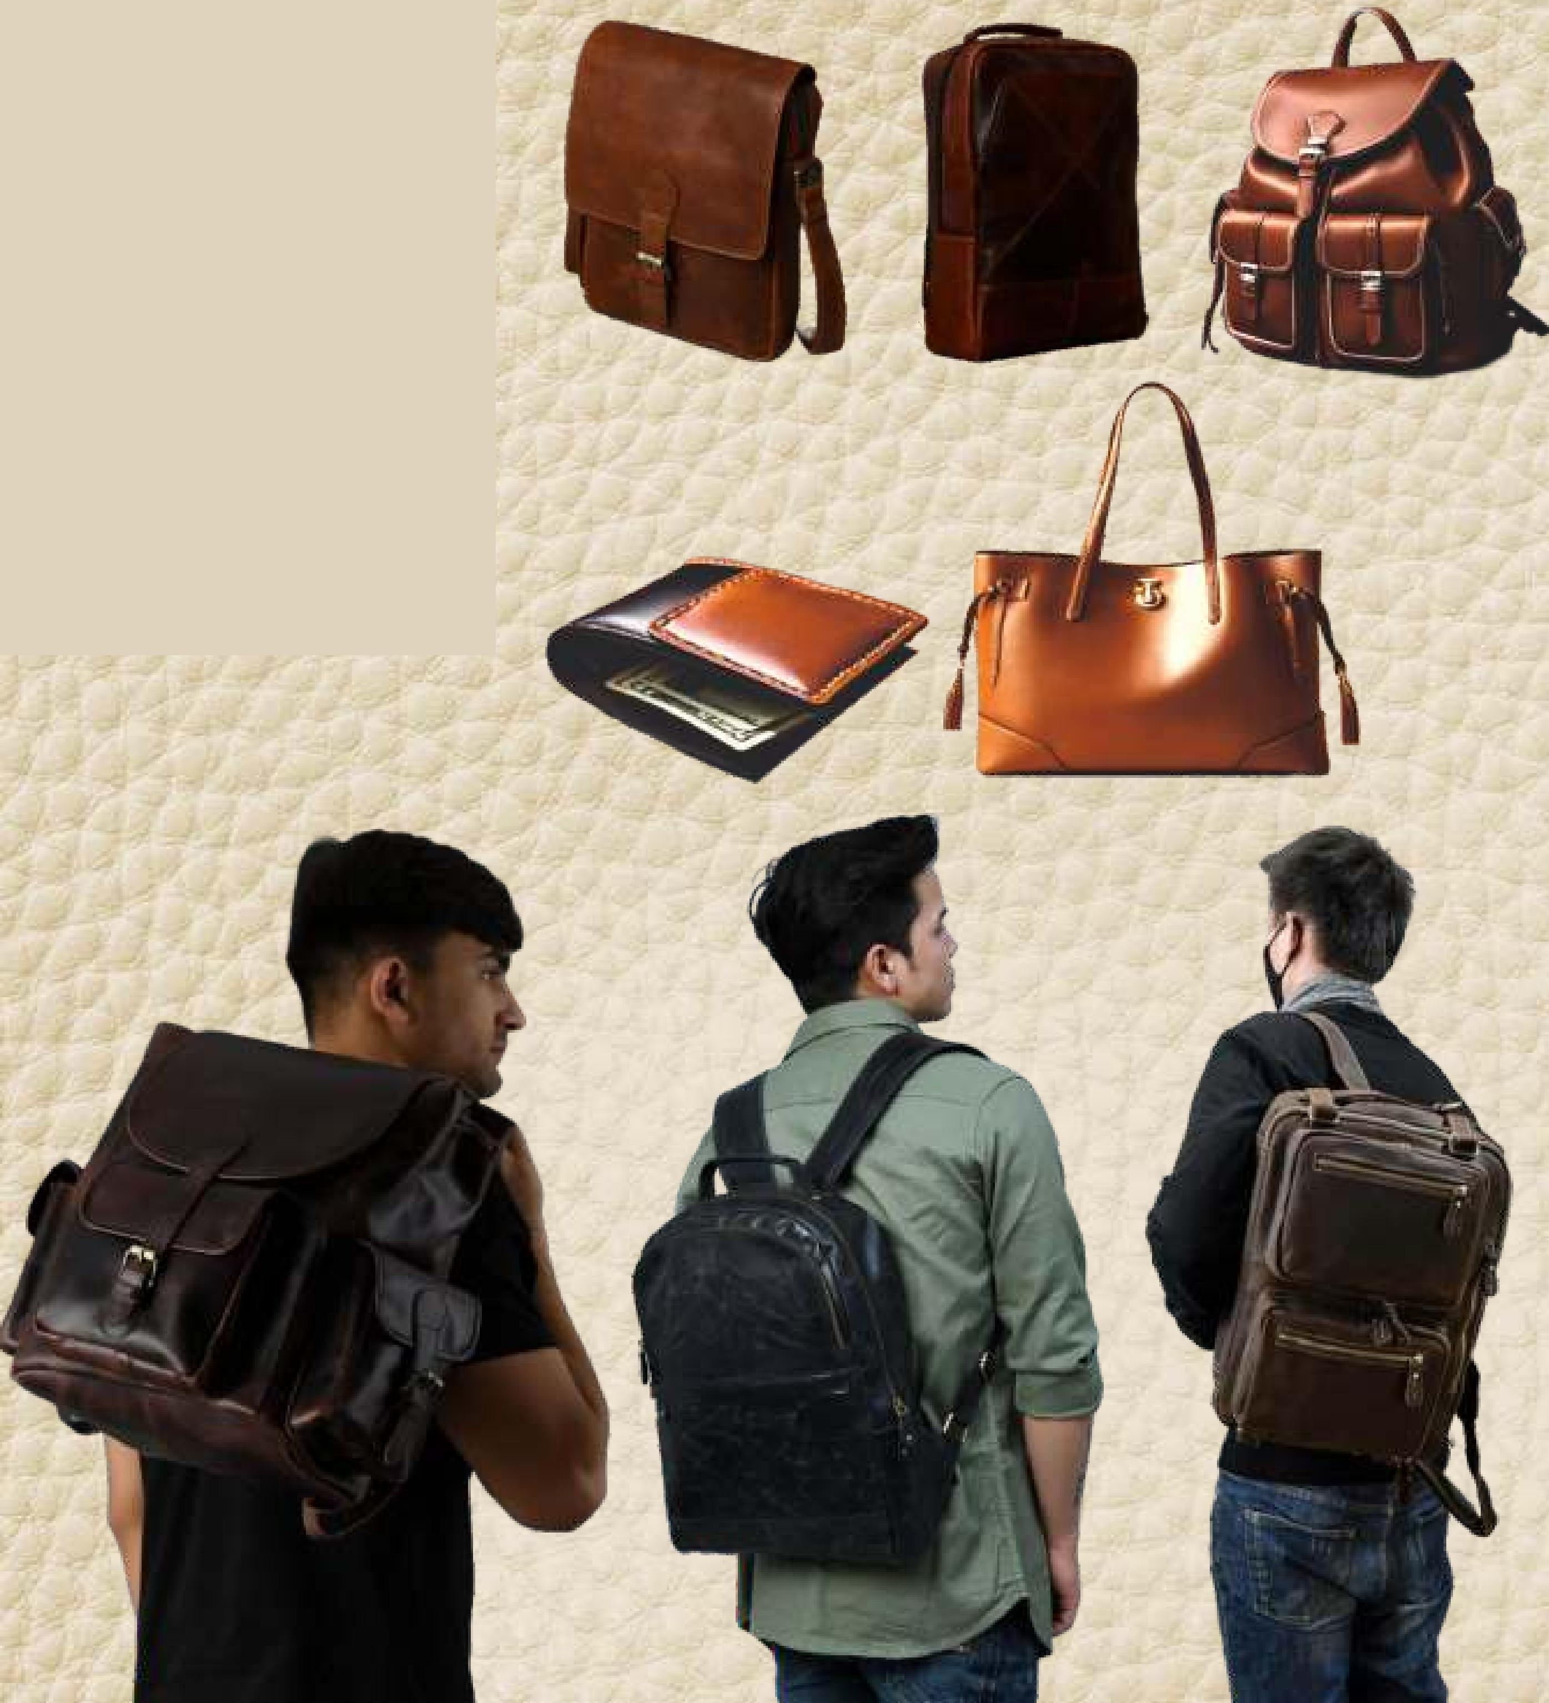**Quality Committed to Quality obligation and Compliance**

**COREVALUES**

**Our vision is to**

**contribute towards environment protection, social needs and by adding highly technical products which will create demand worldwide and creating "Made in India" Brand Equity.**

_

